# How to Self-Enroll in a Course

# How to Self-Enroll in a Course “Engineering and Computer Science Advising”

1. Log into your [MyMC](https://mymc.glb.montgomerycollege.edu/) account.
2. Select the BlackBoard icon on the top of the screen.

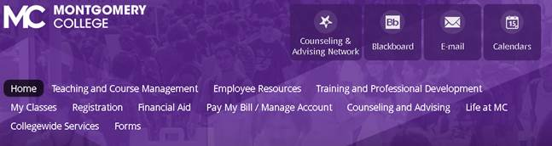

1. Select the Community tab on the top/right of the screen.



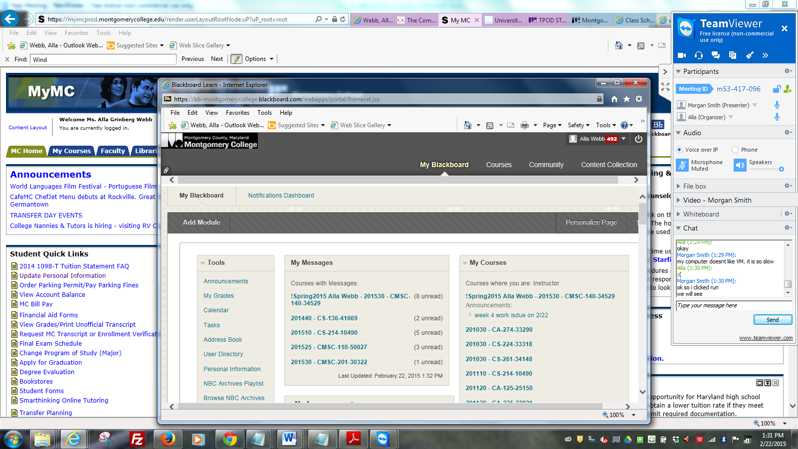

6. This opens the Community page

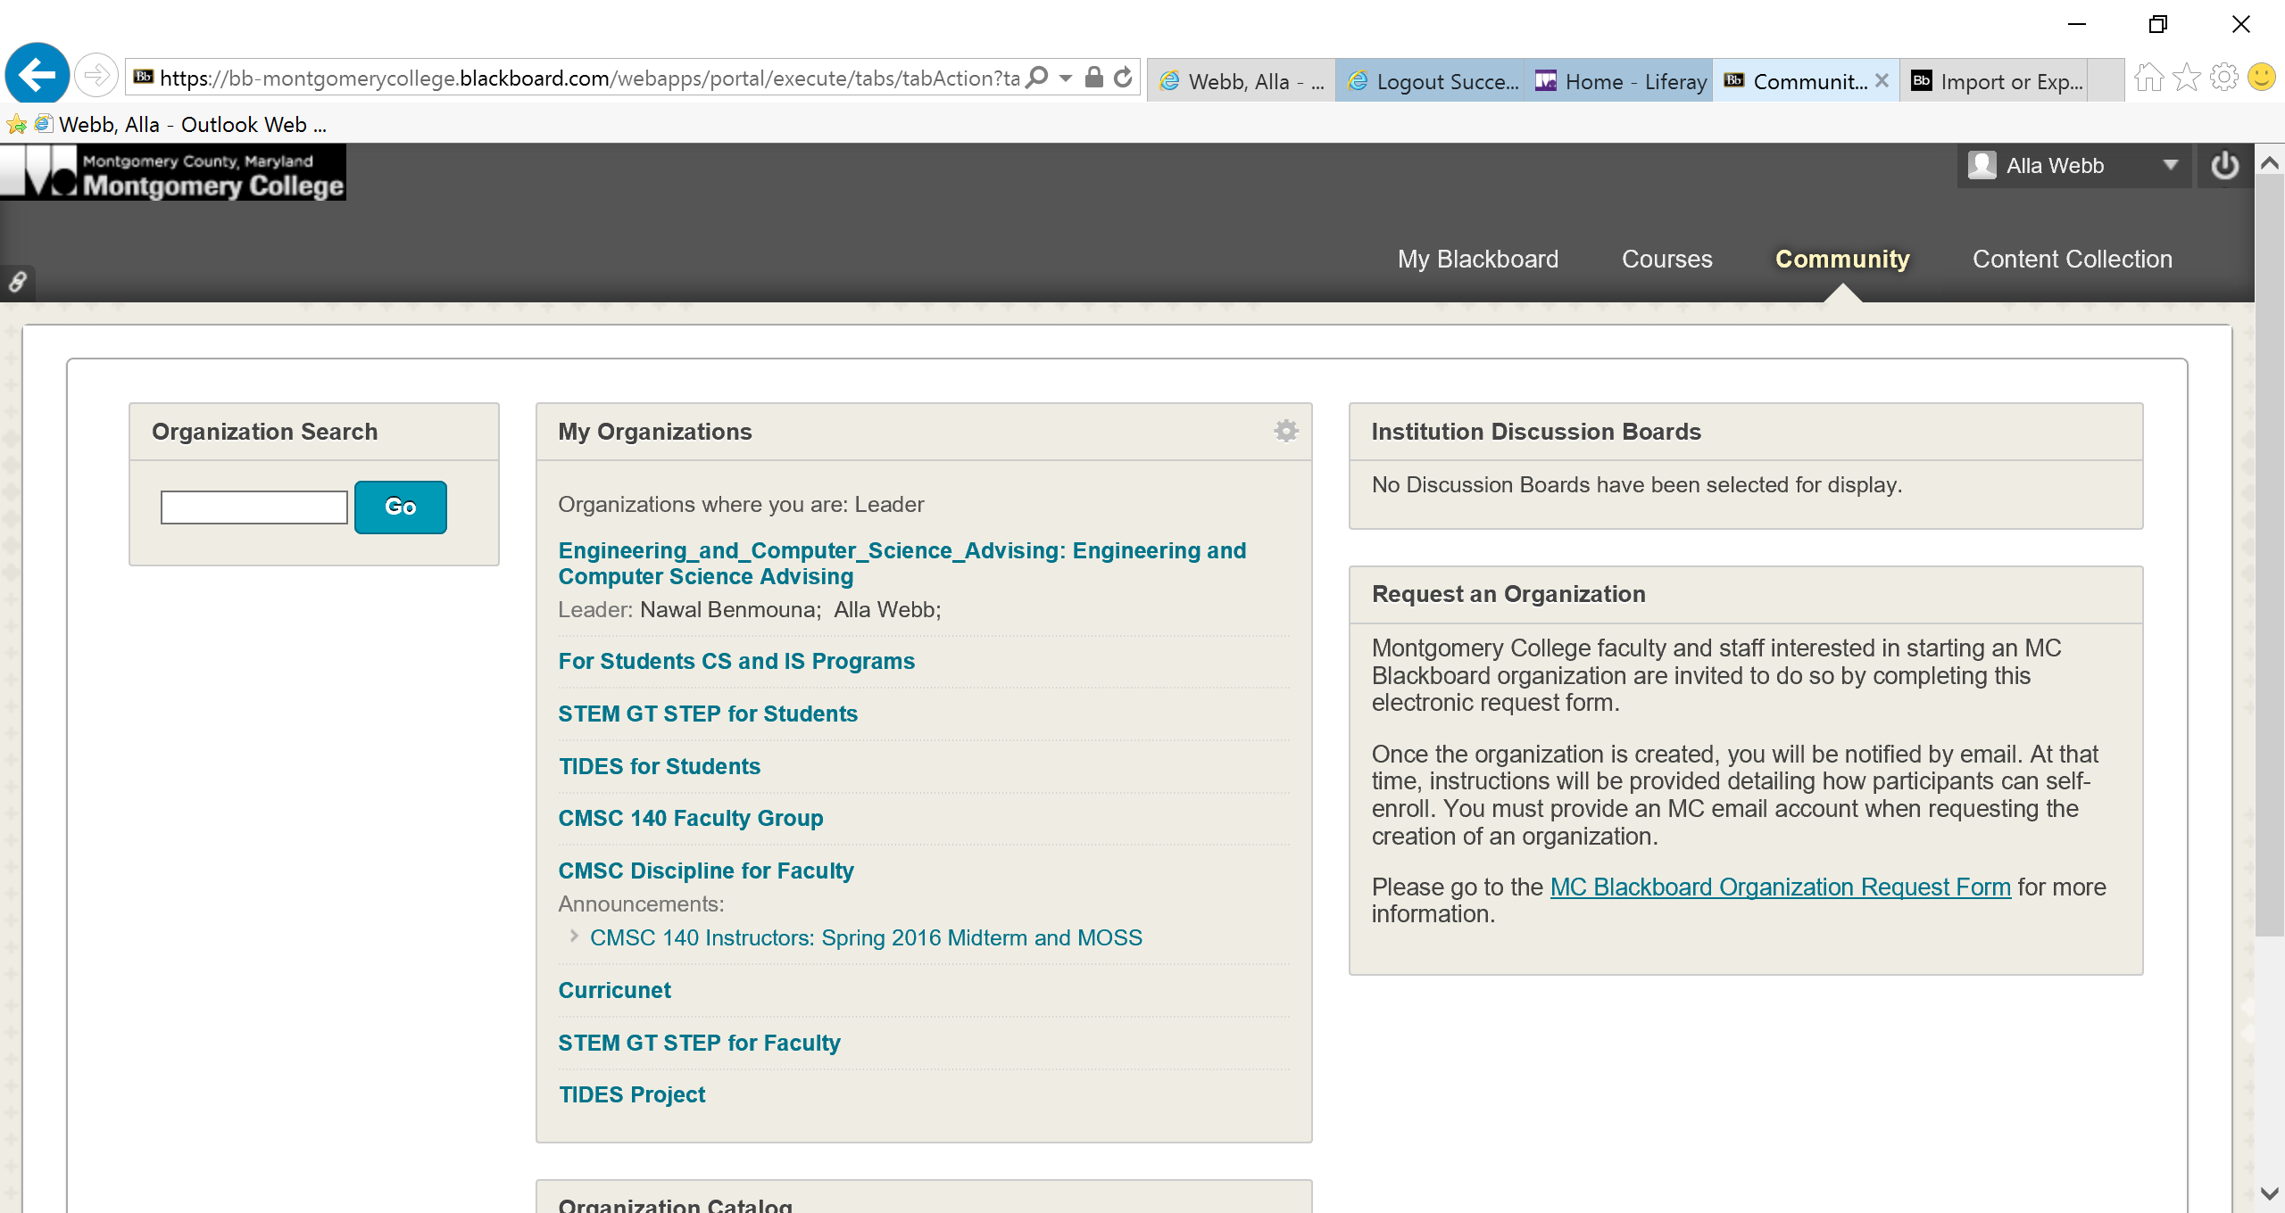

7. In the Organization Search tab, type the name of the course that your instructor has provided

“Engineering and Computer Science Advising” (Engineering is sufficient for the search).

8. Click Go

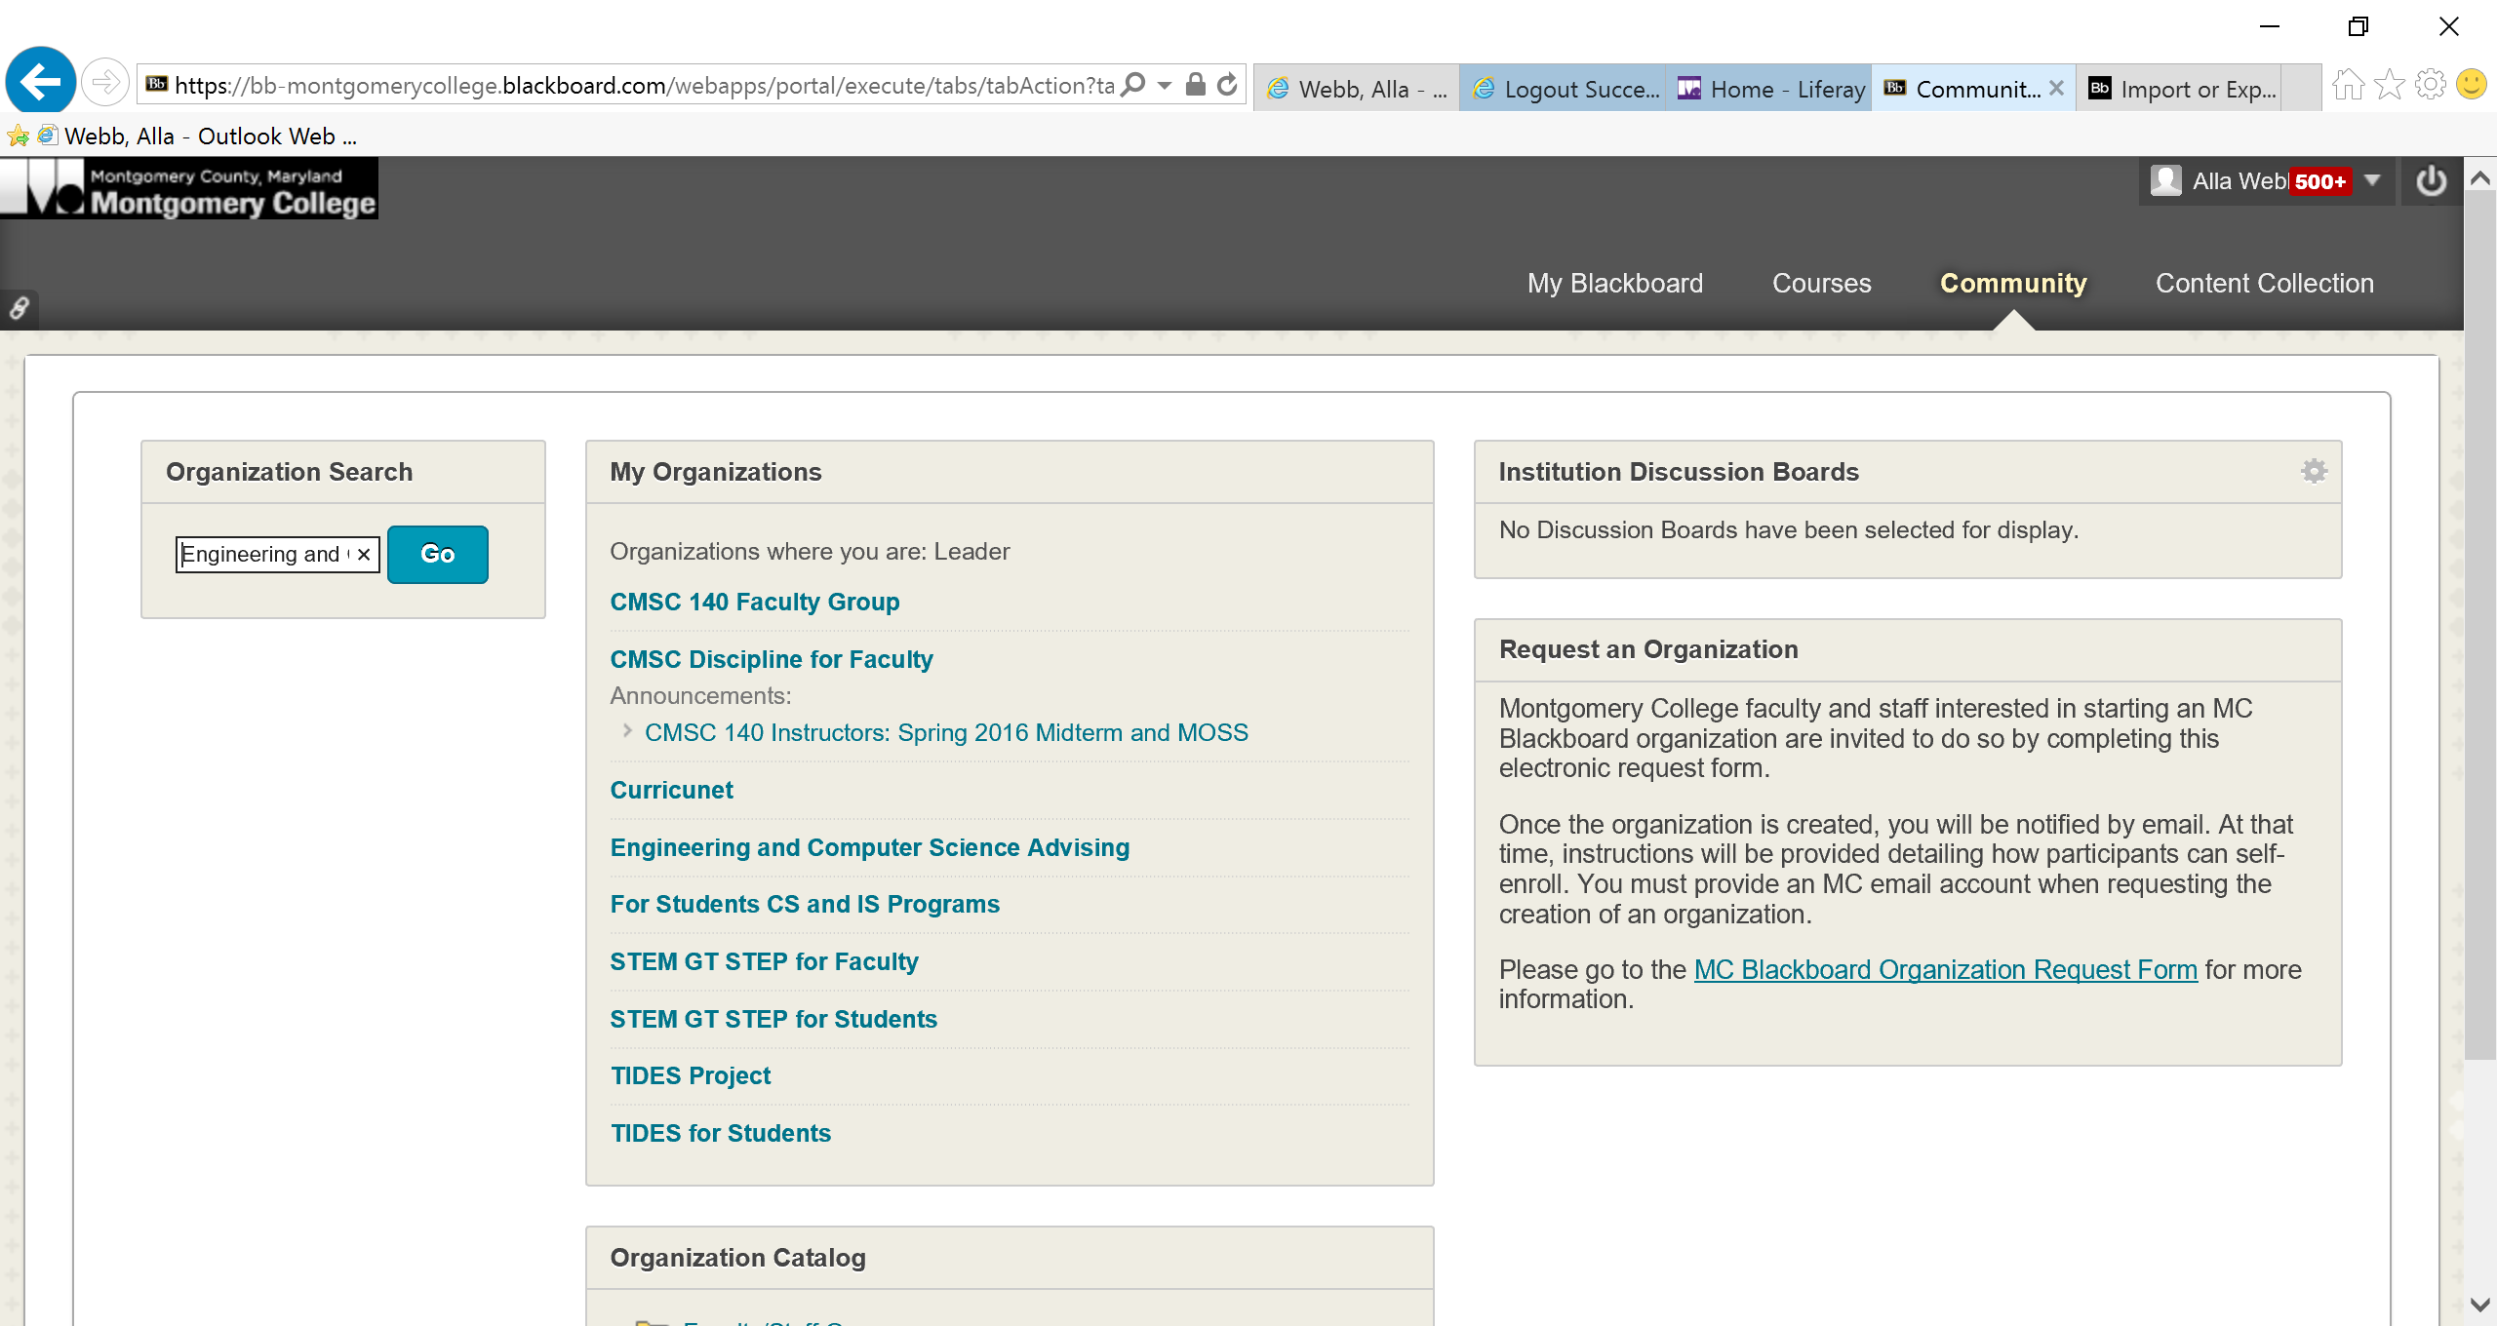

**7.**

**8.**

9. The Browse Organization Catalog page appears. If you typed the correct name for the course, you should see it listed under the Course ID as shown in the image below.

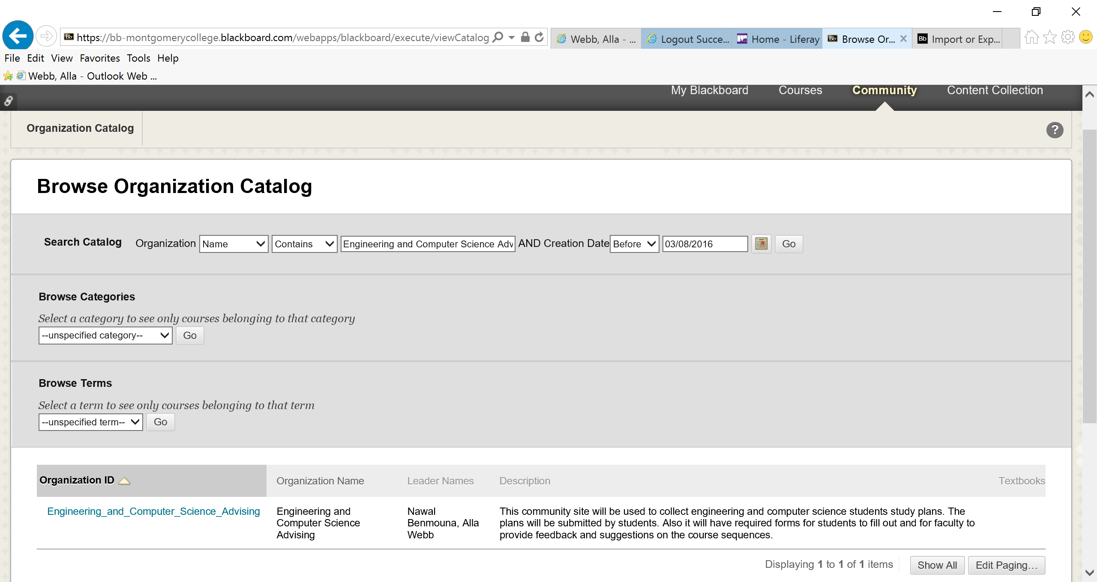

**10.**

10. Click the Action Link to the right of the course Name.

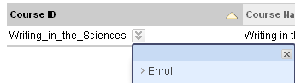

**11.**

11. Click Enroll on the menu that appears

12. The Self Enrollment page appears

13. If the Course selection is appropriate, click  on the Menu that appears

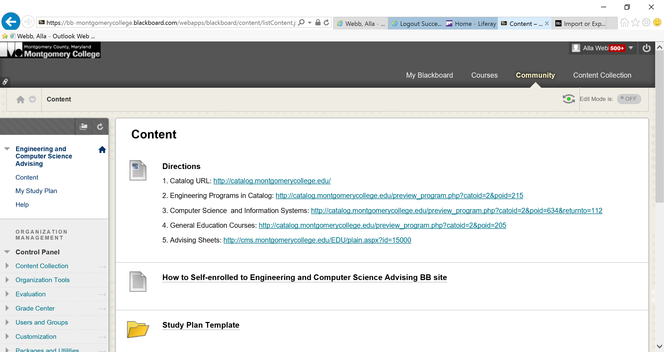

14. Congratulations, you are self-enrolled in the course that your instructor created

15. Click on Content on the left menu